Module 4

Sol-1) p(MPG>38) - total MPG>38/total MPG = 33/81 = 0.469
P(MPG<40) – 61 /81 = 0.753
P(20<MPG<50) - 69/81=0.8518

Sol-2) a) No the data is not normally distributed , it is slightly left skewed or
negatively skewed.
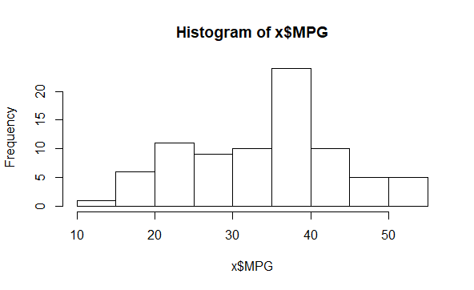
b) No, neither adipose tissue nor waist circumference from wc-at data
follows normal distribution as we can see in the histogram plot that none of them
forming a bell curved shape.

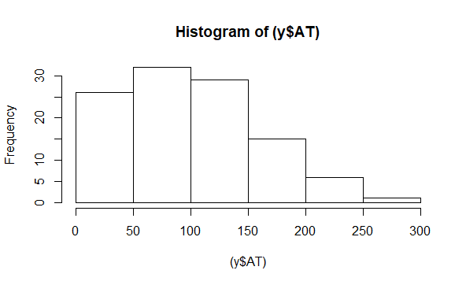
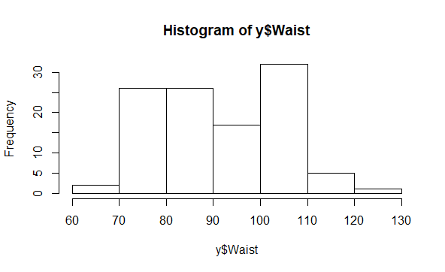
sol – 3) Z Scores
For 90% = +1.65
For 94% = +1.89
For 60% = +0.84

Sol – 4) t scores sampe size = 25
For 95% = 2.064
For 96% = 2.17
For 99% = 2.796

Sol -5)

